**Use Case: Procurement Admin Dashboard**

**Actor:**

* Admin

**Use Case Description:**

* This procurement dashboard acts as the central nerve centre for overseeing and managing procurement activities. The dashboard has various modules that provide a comprehensive overview of the entire procurement landscape, enabling the admin to make informed decisions.

**Trigger Point:**

* The procurement admin initiates this use case when a thorough understanding of the current state of the procurement process is needed.

**Preconditions:**

* The admin is a registered user with valid credentials to log into the system.
* The procurement data is up-to-date and synchronized with the dashboard.

**Post-Condition:**

* Upon successful completion of the use case:
* The admin acquires access to the procurement admin dashboard.
* The dashboard displays the latest procurement data and analytics.

**Normal Flow:**

1. The admin starts the process by logging into the system using their valid credentials.

2. The dashboard loads, presenting an initial overview with the top panel displaying key metrics:

* Purchase Requisitions
* Purchase Orders
* Invoice Count
* Total RFQs

3. The admin explores detailed insights through various panels:

**A. Spend Analysis Panel:**

* Views a dynamic horizontal bar graph representing the top spending categories. This provides a visual breakdown of where the procurement budget is allocated.

**B. Requisition Stats Panel:**

* Examines a detailed donut chart offering insights into requisition statistics. The admin moves to the Requisition Stats Panel, now enhanced to provide more detailed information.
* Within the donut chart, different segments represent the status of requisitions:
* Approved Requisitions
* In Progress Requisitions
* Rejected Requisitions

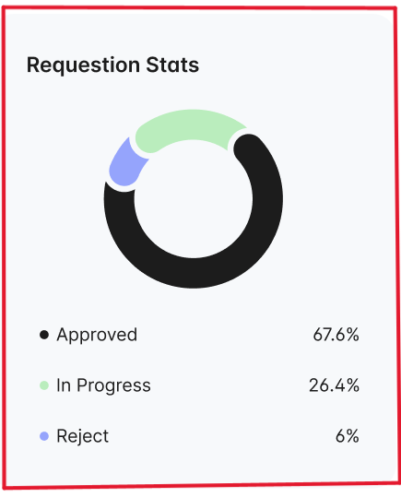

**C. Purchase Order Panel:**

* Analyses a complete line graph that illustrates the status of active, approved, and settled purchase orders throughout the year.
* This helps the admin track the progress and efficiency of the procurement process.

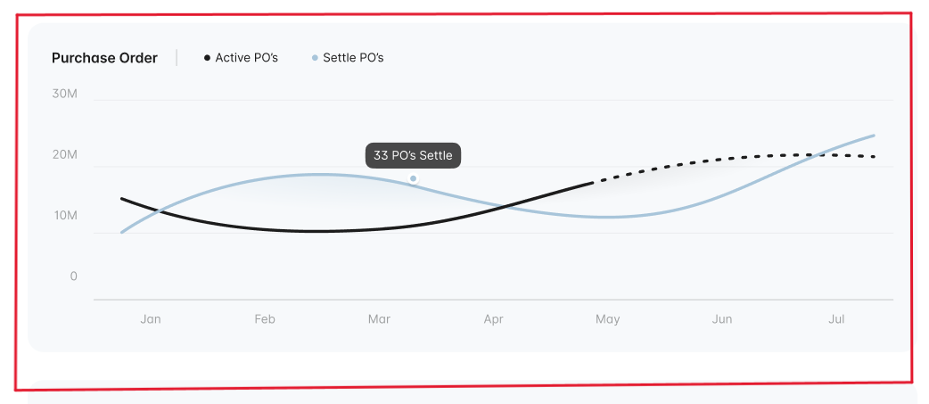

**E. Monthly Expenses Panel:**

* Views a vertical bar graph providing a detailed monthly breakdown of expenses. This enables the admin to identify patterns, forecast future expenses, and ensure budget compliance.

**D. Notifications and Activities:**

* The top right panel provides notifications and activities.
* The admin can view alerts, updates, and recent activities related to the procurement process.

**Alternative Flow:**

* If the admin encounters issues logging in:
* The system prompts the admin to re-enter their password.
* If login issues persist, the admin contacts the IT support team for assistance.